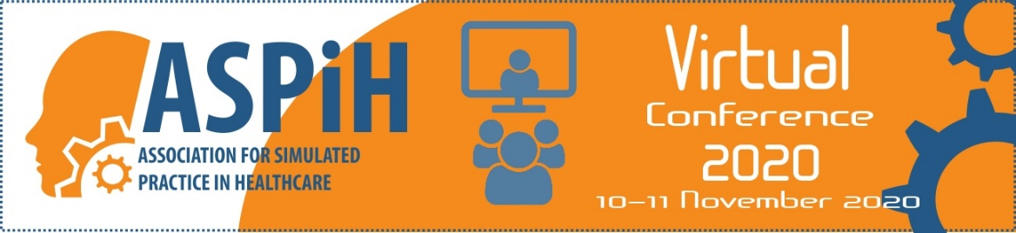

ASPiH Virtual Conference 2020
‘Simulated Practice in Healthcare – the Next Decade’

Tuesday 10th November

0845 | Registration / Logging in / Finding your way
0900–0910 | Orientation of the conference  Colette Laws-Chapman, Conference Director
0910–0930 | Opening remarks and welcome address  Dr Makani Purva - ASPiH President
0930–1015 | Using Simulation to develop empathy  Professor Tracey Levett- Jones –  Professor of Nursing Education University of Technology, Sydney
1015-1100 | Future of HealthCare – Learning from Excellence and COVID19  Dr Adrian Plunkett - PICU Consultant, Birmingham Children’s Hospital
1100-1140 | Refreshment Break & Online Networking
1140-1240 | e-Poster presentations (10) | The Research Studio: Dissecting a manuscript to learn about research  Debra Nestel -  Editor in Chief, BMJ Simulation & Technology Enhanced Learning (STEL) | Oral presentations (4) |  | Advanced/ Virtual Debrief Workshop  Peter Jaye - Director of simulation, Guy’s and St Thomas’ NHS Foundation Trust / Gabriel Reedy – Education and Research Lead, King's Health Partners Simulation and Interactive Learning Centres |  | Science Council Workshop – Introduction to Professional Registration
1240-1340 | Lunch Break & Online Networking
1340–1400 | Virtual Symposium - Gold sponsor
1400-1445 | Work as imagined & work that was done at the Nightingale hospitals  Eamonn Sullivan - Executive members of the NHS Nightingale Hospital London  Bryn Baxendale – Chair, HEE Simulation Advisory & Development Committee  Nicki Credland – BACCN Chair, Nightingale Harrogate Education Lead, Senior  Lecturer and Head of Department, University of Hull
1445-1505 | ASPiH AGM
1505–1530 | Virtual Walk and Talk – we invite you to wrap up and take a short walk and continue to talk
1530-1600 | Refreshment Break & Online Networking
1600–1700 | e-Poster presentations (10) | Oral presentations (4) |  | Oral presentations (4) |  | Ergonomics & healthcare Workshops  Michael Moneypenny – Consultant,  Forth Valley Royal Hospital and ASPiH President Elect  / Al Ross - Senior Lecturer in Human Factors in Healthcare, University of Glasgow
1700-1715 | Closing remarks & 2021 conference promotion (inc signpost to evaluation links & certificate of attendance)
 | Break
1930–2030 | Virtual reception
2030 | Close

Wednesday 11th November 2020

0800 | Refreshment Break & Online Networking
0900-0915 | Welcome & housekeeping
0915-1000 | The future of simulation and technology enhanced learning  Panel Discussion including representation from HEE  Dr Neil Ralph - Head of Technology Enhanced Learning at Health Education England
1000-1020 | Virtual Symposium - Gold sponsor
1020-1100 | Refreshment Break & Online Networking
1100-1200 | e-Poster presentations (10) | Journal club: What are the Editors-in-Chief of @STEL_BMJ and @ClinSimNursing talking about?  Debra Nestel -  Editor in Chief, BMJ Simulation & Technology Enhanced Learning (STEL) | Oral presentations (4) | Oral presentations (4)
1200-1215 | Virtual Symposium
 | Short break
1230-1310 | Virtual and actual conversations - adapting to our new world with simulated patients  Carrie Hamilton - Director of Education at SimComm Academy, Senior Lecturer in adult nursing at Portsmouth University
1310-1350 | Presentation title TBC  Professor Roger Kneebone, Imperial College London
1350 | Closing remarks & 2021 conference promotion (inc signpost to evaluation links & certificate of attendance)

